**Report on the Neural Network Model**

**Overview of the Analysis:**

Alphabet Soup wants to develop an algorithm for forecasting the success of applicants' funding. Leveraging the power of machine learning and neural networks, our goal is to construct a binary classifier capable of predicting whether funding applications will be successful or not.

**Results:**

**Data Preprocessing:**

**-** Target Variable:The goal is to predict "IS_SUCCESSFUL," where 1 indicates success and 0 indicates failure.

- Feature Variables:Analysis was conducted on "APPLICATION" data, and "CLASSIFICATION" was used for grouping.

- Excluded Variables:"EIN" and "NAME" were initially dropped as they had irrelevant information. Later, "NAME" was added back for a secondary test involving binning. It was subsequently split for training and testing.

**Compiling, Training, and Evaluating the Model:**

-How many neurons, layers, and activation functions did you select for your neural network model? Three layers were employed in each model after applying Neural Networks.

* Were you able to achieve the target model performance?

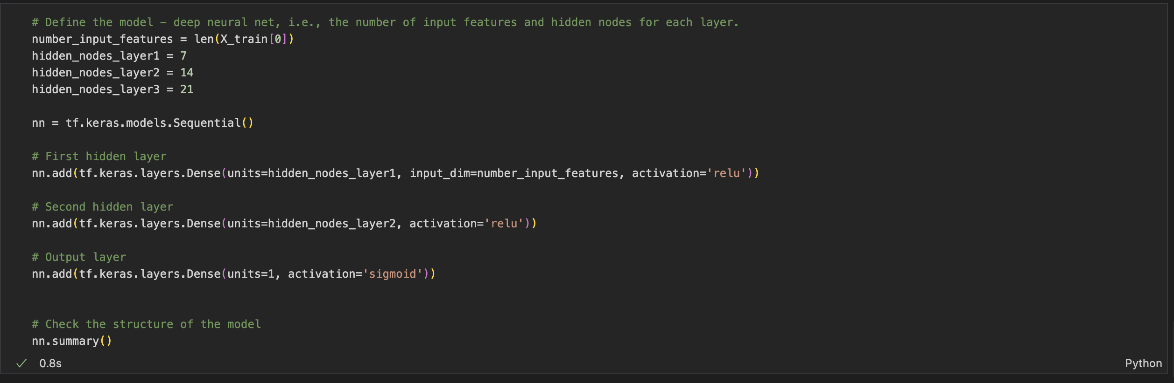

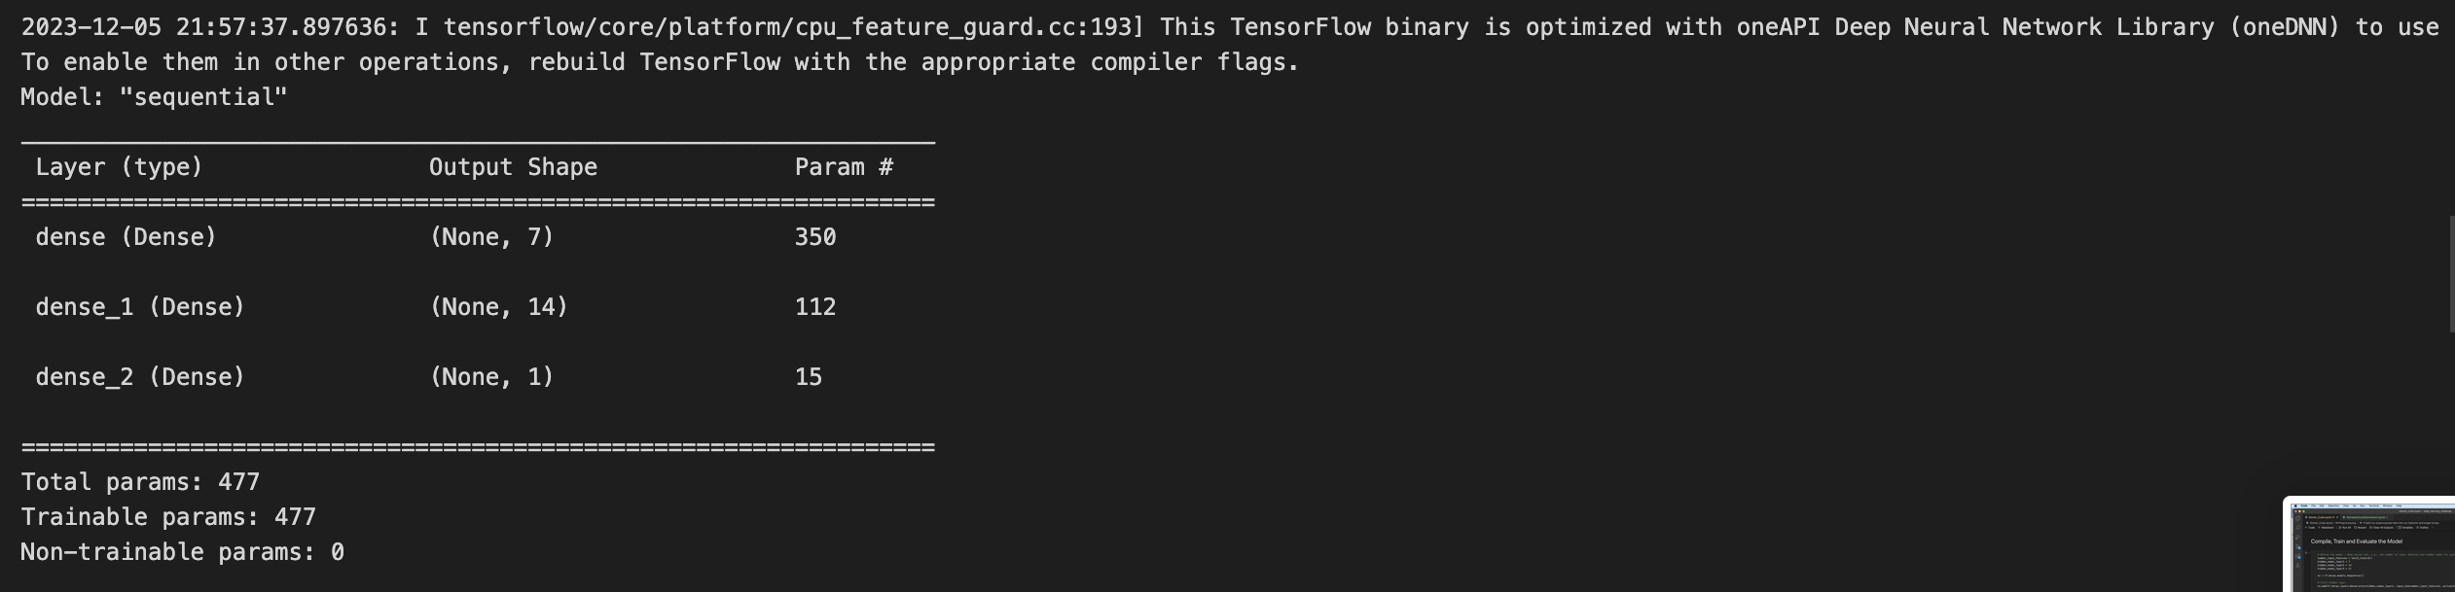

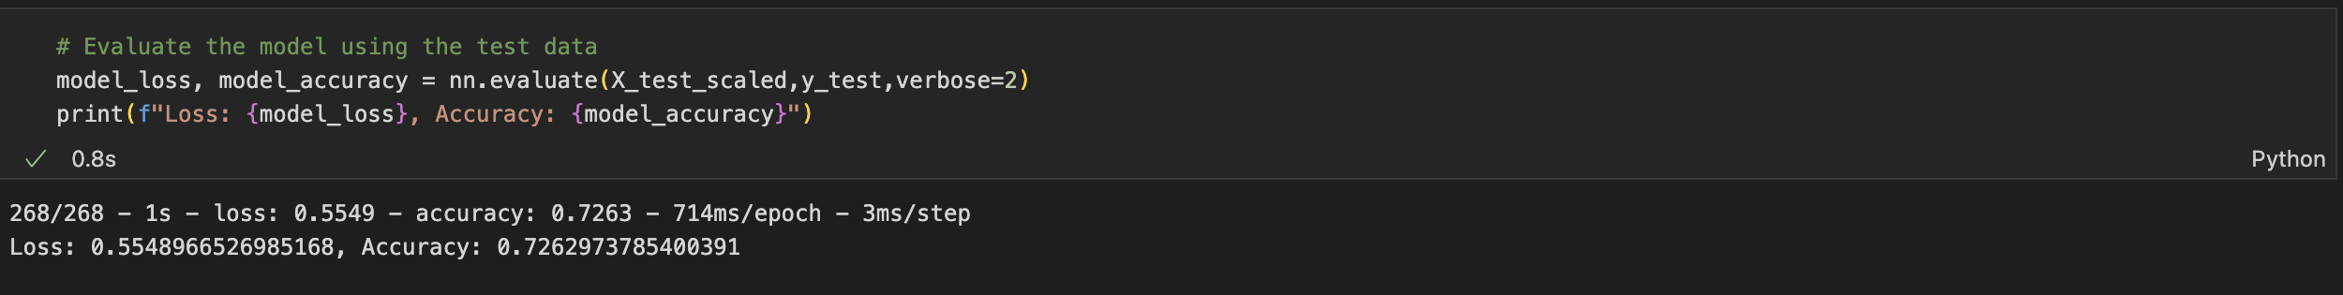

350 parameters were created by the three-layered training model. The first attempt was at 72.25% Accuracy so I wasn’t able to achieve to reach the 75% goal.

* What steps did you take in your attempts to increase model performance?

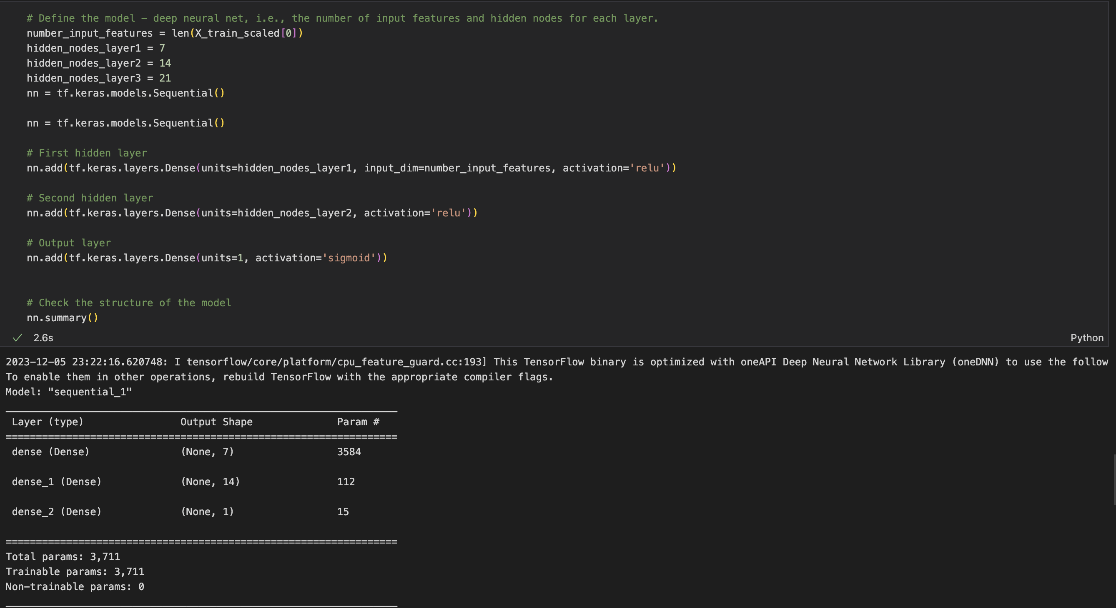

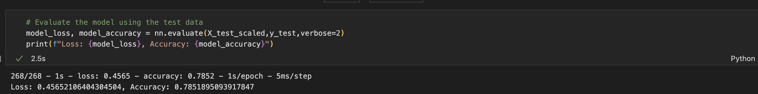

Conclusion

The progression from 72% to 78% accuracy between the two attempts suggests that refinements, such as the inclusion of “NAME” in the second attempt, contributed positively to the model’s predictive capability. Overall, the project is moving in the right direction, and further iterations and enhancements could lead to a more robust and accurate funding success prediction model.